# Conclusions

## Completed or Nearly Completed

* While dynamic amplification is dependent on many factors, the roadway profile is the most influential.
* The total response of a bridge to dynamic loading can be broken into 2 components:
  + The response due to the acceleration of the mass of vehicle Response due to the acceleration of the mass of the bridge
* The vehicle contact force is a result of a coupled dynamic system. The contact force cannot be accurately computed by considering only the vehicle’s interaction with the profile when the profile is harmonic.
* The vehicle contact force (magnitude, maximum) can be reasonably approximated by considering only the vehicle’s response to the profile when that profile is transient in nature as is seen in real profiles.
* Vehicle contact force, computed without consideration of the bridge, cannot be accurately used to predict bridge response, especially when the bridge is subjected to sequential vehicle crossings.
* Dynamic amplification factors, when computed as the ratio of total dynamic bridge response to bridge response due only to a static vehicle, will be greater when computed for displacements than when computed for moments, stresses, and strains. This is due to the fact that the bridge response is due to the vehicle force and the accelerated mass of the bridge, but is forced to be expressed as a function of only the vehicle force
* Vehicle response is greatest when the profile contains frequency content that produces a forcing frequency equal to the vehicle’s first natural frequency. The vehicle response to a profile has been studied and is extensively covered in this paper: (Camara et al. 2017).
* Bridge response is greatest when the profile has frequency content that produces a forcing frequency just below the bridge’s natural frequency (≈0.9fn), and the vehicle has a natural frequency near and above the bridge’s natural frequency.
* The dynamic amplification (resulting from the profile) can be reduced by enforcing a smooth profile
  + Removing profile frequencies corresponding to the bridge natural frequency.
  + Straightedge requirements: 1/8” over 20ft keeps amplification under 1.33
  + Profiles with low IRI will have low amplification
  + Profiles with high IRI may have large amplifications depending on the spatial frequency content (or waviness)
* IRI is a metric capable of describing the amplitude of the profile but the waviness is needed to describe the distribution of features with different wavelengths.
* While profile frequency content has an effect on bridge response amplification, phase angle distribution contributes large variability. Therefore, the specific profile must be analyzed.
* Vehicle-bridge interaction can be estimated with simplified models (i.e. single-line beam model), but the model must be capable of accurately predicting the first vertical (global) mode and must have an accurate mass and stiffness distribution as well as accurately model span continuity.
  + For best results, compute mass and stiffness from deflection (unit load or otherwise) and first natural frequency.

## To Be Completed

* Repeated vehicles can result in greater dynamic amplifications. Amplification can be expected to be increased by no more than XX%.
* Amplification from random traffic may be XX% more than from a single vehicle crossing.
* Truck trains should avoid regular spacing (headway) and the headway should be limited to minimize dynamic amplification.
* Approach slope (difference) should be minimized to reduce dynamic amplification.
  + Amplification can be correlated to approach slope according to: XX=AYY.

## Weak or Boring Conclusions

* A vehicle traveling over a bridge that is oscillating at a frequency (fn) will experience a transformed bridge motion, whereby the “felt” motion is the sum of two frequency components equal in magnitude. The frequency of these two components can be described by: $f_{n}±\frac{Nv}{2L}$. Therefore, the vehicle experiences a positive and negative shift in frequency (displacement, velocity, or acceleration) according to the vehicle velocity and the distance between modal points for that mode of vibration.
* Based on 2DOF system simulations, the displacement of a bridge due to dynamic vehicle loads is a function of bridge mass and stiffness, profile acceleration corresponding to frequency content at or near the bridge natural frequency, the mass of the vehicle, and to a lesser extent the damping of the bridge and vehicle. The displacement is directly related to truck mass and profile acceleration, and indirectly related to bridge mass, bridge damping and vehicle damping.

# Work Plan

Start with tools. Show that FE is capable, then show that single-beam (single and double span) is adequate for certain scenarios, and when it is no longer capable. Then show when just a quarter car model is sufficient (contact force). In this way we demonstrate tools for determining dynamic amplification and the procedure for determining the appropriate tool for a given scenario (bridge and profile characteristics.

Use these simplified tools to demonstrate the adequacy of current local roughness standards to keep amplification at acceptable levels. Propose alternative criteria that would better serve to reduce amplification.

How will multiple vehicles effect dynamic amplification? Are there problematic truck spacings and are there spacing that minimize dynamic amplification.

# Outline

1. The nature of dynamic amplification and Vehicle-Bridge Interaction
   1. Background
      1. Explanation of phenomenon (i.e. excitation of bridge mass)
      2. Displacement vs stress amplification
   2. Mechanisms and parameters
2. Profile management with smoothness criteria
   1. Rolling straight-edge criteria (x” deviation over y ft.)
   2. IRI upper limits
3. Tools for estimating dynamic amplification
   1. FE model
      1. Illustrate suitability with I-76 StID
      2. Included modes
      3. Vehicle degrees of freedom
   2. Vehicle-model (quarter-car)
      1. IRI correlation with FE computed amplification
      2. Windowed contact force correlation with FE computed amplification
   3. Double-sprung mass
      1. Displacement amplification correlation with FE computed amplification
   4. Vehicle-bridge model (2-dof state-space)
      1. Displacement amplification correlation with FE computed amplification
4. Effect of special loading on dynamic amplification
   1. Repeated loading: how much is amplification increased
      1. Worst-case: phase of new vehicle contact force corresponds to bridge motion
      2. FE simulations with various random traffic conditions
   2. Truck trains and headway control
      1. Can repeated heavy vehicles cause greater bridge excitation
      2. Is it possible to have a problematic headway pattern
      3. Is there a headway pattern that eliminates risk of high amplification
   3. Settled approaches
      1. Do settled approached present hazard to bridges or is the excitation too broadband
      2. Can a relationship be developed between amplification, ramp slope and bridge length
      3. Can a relationship be developed between bump/fault (i.e. sudden jump or drop in profile) at the beginning of the bridge and amplification
5. Spatial variability of dynamic amplification
   1. Flexure away from mid-span
   2. Amplification of shear
   3. Multiple continuous spans
      1. Compare single span to 2-span continuous
      2. Ability of tools to estimate amplification
      3. Develop 2-span simplified model

# The nature of dynamic amplification and vehicle-bridge interaction

## Background

### Displacement vs. stress amplification

In many pieces of relevant literature, experimentally derived dynamic amplification factors are reported for both displacement and stress or strain. The displacement factors are almost always greater than those for stress or strain. If a bridge behaves linearly then its response should be linear (i.e. an increase in load by a factor X will result in an increase in response by the same factor, X) regardless of whether the response in question is global (e.g. displacement) or local (e.g. stress, strain). This is not the case with dynamic amplification factors because of a violation of the key assumption that the measured response is due solely to the applied load.

Dynamic amplification factors assume that the bridge response is due to a vehicle which applies a force equal to its weight increased by a factor to account for its dynamic motion (acceleration > gravity). If this assumption were true, dynamic amplification factors would be equal for the various response quantities. However, the bridge response is due not only to the force applied by the vehicle but also the force due to the acceleration of the mass of the bridge as it is excited by the dynamic vehicle force (or other excitation sources).

Furthermore, displacement is the accumulation of curvature which is linearly related to moment elasticity ($u^{''}\left(x\right)=\frac{M}{EI}$), while stress is just linearly related to moment. Therefore a distributed load that causes a given stress equal to that caused by some point load will result in a displacement greater than that caused by the same point load as illustrated in the following plots.



A complete derivation can be found in the appendix.

## Mechanisms and parameters

The amount of dynamic amplification experienced by a bridge is dependent on many parameters, including bridge geometry, stiffness, weight, and damping; vehicle weight and suspension characteristics. However, the most influential parameter is the roadway profile over the bridge.

### Roadway Profile

A full 3D FE model was constructed to illustrate the effect a profile has on bridge response. The model is 140 feet long with four (4) steel girders, a concrete deck and concrete barriers. A simulation was subsequently performed, whereby a vehicle was run across the bridge deck over a profile that was measured on an in-service bridge.

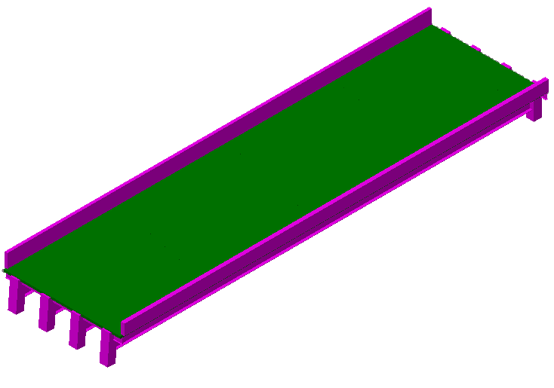 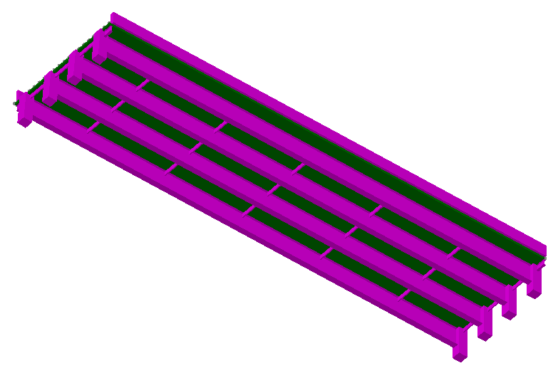

The plot below shows the displacement of the first interior girder at midspan due to a 77 kip vehicle traveling at 720 in/sec (40.9 mph).

We may also examine the contact force applied by the vehicle to the bridge model. This contact force is amplified by the motion of the vehicle over the profile and bridge. However, the amplification of this contact force when the vehicle is near mid-span is less than the bridge response amplification. This is because the moving vehicle is exciting the mass of the bridge, thereby inducing vibrations.

#### Profile Frequency Content

Since the profile has such a large influence on bridge response and amplification, it is useful to understand the characteristics of a profile and their impact on bridge response. The profile may be thought of as a summation of harmonic functions, and therefore a profile may be described in part by its spatial frequency content. In an effort to understand the impact this frequency content has on bridge response, a series of simple harmonic profiles were created with varying spatial frequencies. The amplitudes of these profiles were scaled to have equal IRI values. The spatial frequency (*f*s) of these profiles corresponds to a temporal frequency (*f*t) depending on the velocity (*v*) of the vehicle according to the equation:

$$f_{t}=f_{s}*v$$

The table below lists the spatial wavelengths (1/*f*t) and corresponding temporal frequencies of the artificial profiles investigated for a vehicle speed of 720 in/sec (40.9 mph).

|  |  |
| --- | --- |
| Wavelength | Frequency (*f*t);  v = 720 |
| 240 in. | 3 |
| 360 in. | 2 |
| 480 in. | 1.5 |
| 720 in. | 1 |

Simulations using a 3D FE model were performed with these different profiles. The resulting bridge response is plotted below.

Plot Placeholder

As can be seen the bridge response is greatest when the profile frequency results in a forcing frequency near to the bridge natural frequency. To better understand the interaction between profile frequency, bridge natural frequency, and vehicle natural frequency, a simplified model was employed for a larger parametric study. This model simplified the bridge and vehicle into two sprung masses. This model is fully described in the appendix.

The vehicle stiffness was varied to produce vehicle models with natural frequencies between 1 and 5 Hz. Similarly the bridge model stiffness was varied to produce natural frequencies that also ranged between 1 and 5 Hz. Simulations were performed with varied speeds, resulting in various temporal frequencies. Further details of this study can be found in the appendix. The following plots illustrate the interaction of vehicle, bridge and profile frequency.

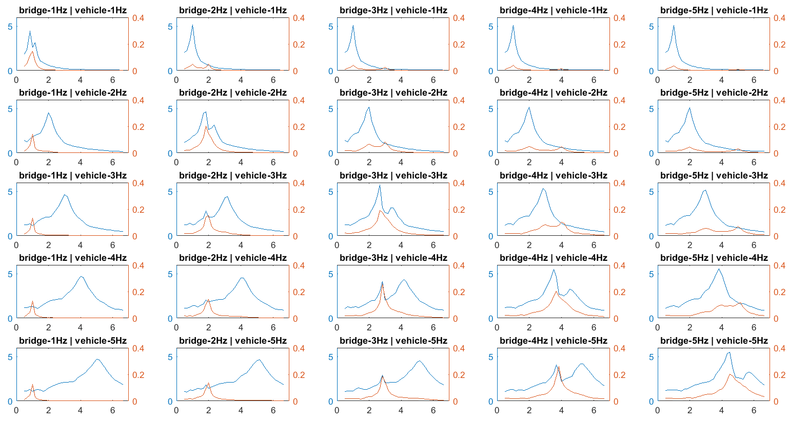

In the previous plots, the right-axis is the ratio of bridge-mass displacement to its displacement under self-weight while the left axis is the ratio of vehicle acceleration to maximum profile acceleration (2nd derivative of profile). The bottom axis is the temporal frequency of the profile. From these plots we may deduce that while the vehicle may experience the greatest response when the profile temporal frequency matches the vehicle natural frequency, the bridge response is greatest when the profile temporal frequency matches the bridge natural frequency and the vehicle natural frequency is near and greater than the bridge natural frequency.

While the previous parametric study provides understanding of the relationship between vehicle, bridge and profile frequencies, it is necessary to consider more realistic profiles which contain many spatial frequencies. Through the power of the fast-Fourier transform (FFT), the distribution of frequency content may be quantified. This process for roadway profiles has been formalized in the ISO 8608 standard. The standard fits an exponential equation to the Power Spectral Density (PSD) of the profile in the form of Gd(n)=Cn-w.

Furthermore, we may construct an artificial profile by summing harmonic functions for which the spatial frequency and amplitude of these functions can be specified by an equation of the same form ($G_{d}=Cn^{-w}$). The following plot displays the PSD of the measured profile and the fitted ISO 8608 function.

Plot Placeholder

Artificial profiles were generated based on the above fitted function. The waviness (w) was varied while the amplitude parameter (C) was assigned to produce equal PSD amplitude (Gd) at spatial wavelength (1/n) equal to 10 meters. The following plot shows the resulting equations.

Plot Placeholder

The above equations produced profiles that were then used in simulations using a 3D FE model. The generated profiles are plotted in the appendix. The bridge response to the different profiles is plotted below.

Plot Placeholder

As can be seen from the above plot, profiles with greater frequency content near the bridge natural frequency result in greater bridge response. However, frequency content cannot alone describe the frequency content. The phase angles of the frequency contributions as well as the location of the profile on the bridge may influence bridge response. To investigate the effects of phase angle distribution, several profiles were generated with identical frequency content but different phase angles. The phase angles values were assigned randomly from a uniform distribution. Simulations with these profiles were performed with a simplified 2-dof beam model as described in the appendix. The plot below shows a histogram of the resulting bridge displacement amplification.



The cases for maximum and minimum amplification are plotted below:



Figure 3: Profiles with varying phase angles



As we can see in the above plots, the phase angle of the profile can have a large effect on bridge response. Simulations were also performed with a single profile (same frequency content as used in previous study) with the starting position varied (i.e. profile shifted on bridge) resulting in large variation in bridge displacement amplification, further demonstrating that the unique spatial characteristics of the profile must be considered for accurate estimation of dynamic amplification. The following plot illustrates the bridge displacement amplification for varying profile positions.



#### Summary

* The bridge roadway profile is the most influential parameter to bridge dynamic amplification.
* Profiles with high amplitudes of spatial frequency content that correspond to temporal frequency equal to the bridge natural frequency at the vehicle velocity will result in increased bridge dynamic amplification
* Bridge dynamic amplification is further increased when the vehicle has a first natural frequency (body bounce) near to and greater than the bridge natural frequency.
* The bridge dynamic amplification cannot be accurately estimated unless the unique spatial characteristics of the profile are considered. Therefore, simulations must be performed with the actual profile that exists on a given bridge.

# Profile Management

Since the roadway profile is the most influential parameter for dynamic amplification, it would be beneficial for bridge managers to specify roadway roughness limits. Overall pavement smoothness is usually controlled by specifying IRI limits. Localized roughness criteria is usually specified in terms of deviation over a certain length (0.125 inches (3.175 mm) to 0.25 inches (6.35 mm) over a 10- or 16-ft (3 to 4.9-m) straightedge) (*Measuring and Specifying Pavement Smoothness*). However, no specifications are provided for roadway over bridges. This section will examine possible criteria and their effectiveness of reducing dynamic amplification.

## Straightedge Requirements

To assess the effectiveness of straightedge deviation restrictions, simulations were performed with a model that included both the bridge and vehicle with a real profile. The plot below shows the bridge response (mid-span displacement amplification) with that profile, as well as the response with the same profile “smoothed” to meet 1/8” over 10ft criteria.





The smoothed profile performs better, but still results in an amplification of 1.92.

The profile was again filtered to achieve 1/16th inch over 10 feet and the following bridge response was obtained from simulations. A dynamic amplification of 1.6 was still observed. 

Since the deviation specifications had minimal effect of dynamic amplification, the straightedge length was considered and the profile was filtered to meet 1/8th inch deviation over 16 feet. This smoothing of the profile succeeded in reducing the amplification to 1.4. By increasing the straightedge length to 20 feet, the dynamic amplification was further reduced to 1.27.







Asses this (or other straightedge criteria) for a range of bridges to make sure it is sufficient.

## IRI Levels

While it is no surprise that profiles that have high IRI’s can contribute to large dynamic amplifications, it is not obvious if bridges with profiles with low IRI’s are insulated from large dynamic amplifications. To investigate this, simulations were performed with a worst-case profile, which consisted of a sine wave with a wavelength that would result in a forcing frequency equal to the bridge natural frequency. Because of the nature of how the IRI is computed, it is linearly related to the amplitude of the profile. Therefore, the profile was scaled to achieve an IRI of 71 in/mi.

Simulations were performed with this profile and bridge mid-span displacement was recorded.

# Simulation Tools

## FE Models

Finite element models are a valuable tool for representing the physical mechanisms of a structure for the purposed of simulating loading scenarios and obtaining structural responses. As a first step in understanding vehicle-bridge interaction, an FE model was constructed based on an actual bridge and vehicle loading was simulated that corresponded to loading implemented in a field test. In this way, the model’s ability to accurately simulate vehicle-bridge interaction could be assessed.

The exemplary structure was an 11 span multi-girder highway bridge that was reported to have unusually high levels of vibration. Several field tests were carried out to capture operational response levels and to perform structural identification. The test results were used to refine and validate the FE models. Testing was also performed whereby a loaded dump truck, in addition to the bridge, was instrumented with accelerometers and the responses of the two systems recorded synchronously. This data, along with profile measurement, provided the necessary data for model validation.

The plot below compares the model response to the response measured in the field.

The close agreement demonstrates the models ability to simulate vehicle-bridge interaction. For correlation studies using the following simplified models, bridge dynamic amplification was computed with a similar 3D FE model that is of a single simply supported bridge with a span length of 140 feet and four (4) steel girders.

## Quarter-car model

The quarter-car model has been used extensively to simulate vehicle response to road surface roughness. The model consists of a double sprung mass with damping and represents a single wheel, its suspension and a quarter of the vehicle chassis. The equations of motion can be developed for this system, which can easily be expressed in the form of a state-space equation ($\dot{X}=AX+BU$). The matrices A and B were constructed from the equations of motion, and MATLAB was used to run the state-space model. The output of this model includes the vehicle velocity and acceleration time history from which other quantities can be easily computed (e.g. vertical displacement, contact force).

A quarter-car model with specific parameters (golden-car) is used to compute the IRI for a profile by accumulating the vertical displacement of the vehicle. This, as well as other metrics derived from the quarter-car model output, was investigated for correlation to bridge dynamic amplification.

As shown previously, the bridge response is dependent on the location of the profile on the bridge. This is not surprising, as a large amplitude feature near the ends of the bridge will contribute much less to the bridge response than a feature near the middle of the bridge. Therefore, the vehicle response will be windowed with a half sine wave with a wavelength equal to twice the bridge span length. In this way the vehicle response at mid-span may be accentuated while the responses near the ends of the bridge are diminished. The following plot shows the correlation between the amplification of bridge displacement and vehicle response (IRI and windowed contact force).

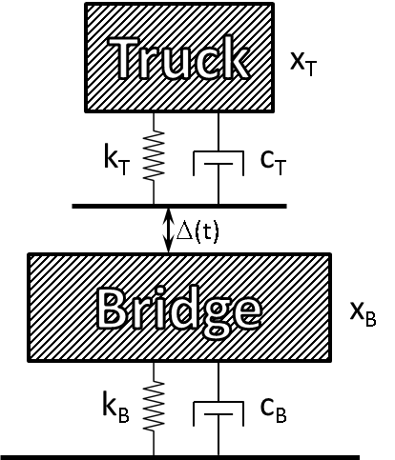It is evident from the previous plot that bridge dynamic amplification cannot be estimated without consideration of bridge behavior. Therefore a model that includes the bridge system should be implemented.

## 2-DOF vehicle-bridge model

This model reduces the vehicle and bridge each to a single sprung mass as depicted in the figure. The equations of motion were developed for this simple system and a state-space model constructed. While this model may seem excessively simple, its simulation output is useful for understanding the interaction between the vehicle and bridge was investigated for correlation to bridge dynamic amplification.

For this model, the bridge mass was set to 64% (integral of a half-sine with an amplitude of 1 ≈ 2/π) of the total bridge mass based on the assumption that bridge will deform with a half-sine shape. The bridge and vehicle spring stiffness were assigned values to obtain natural frequencies corresponding to those in the FE model.

The following plot shows the correlation between the displacement amplification computed with this 2-dof model and that computed with the 3D FE model. Because this model ignores the spatial aspects of the bridge system, the bridge response is windowed with a half-sine wave to emphasize responses when the vehicle is at midspan.

## 2-DOF vehicle-bridge model with distributed mass and elasticity

This model reduces a simply supported beam to a single degree of freedom using an assumed displacement shape function with a moving sprung mass to represent a vehicle.

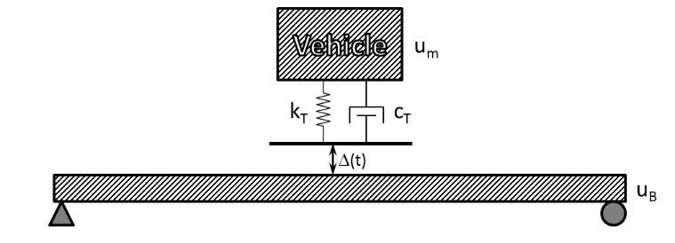

While this model drastically simplifies the bridge system, it can be shown to produce bridge displacement with sufficient accuracy (as seen in the appendix). The simulation outputs were investigated for correlation to bridge dynamic amplification.

It should be noted that this model assumes uniformly distributed mass and stiffness, a specific displacement shape, and ignores any transverse effects due to it being reduced to a 2D beam. If the structure is exceedingly complex (e.g. heavy skew, mass or stiffness varying significantly along the bridge’s width or length, multiple spans), a 3D FE model should be employed.